Track 6: Smartphone-based Vehicle positioning without additional equipment
Organizational aspects:
Database/dataset download:
- Participants can download the databases (logfiles) from this site: http://evaal.aaloa.org
Competitors can only use the data provided for the competition.
Submission of the post-processed results:
- After processing the evaluation logfiles, participants must submit the position estimates to the contact points of the corresponding track. Each submission must fulfill the format detailed in “Output location file format” described below.
- A participant team can upload up to 3 different contributions, which will be evaluated by the competition organizers. Although the three alternatives will be evaluated on the final test set, only the best one will be considered for the contest.
Submission deadline of the post-processed indoor coordinates:
The deadline for submitting the post-processed results is: November 30th 2020
Competition Goal:
The goal of this track is to evaluate the performance of different integrated navigation solutions based on the sensors of vehicle-mounted smartphone, such as GNSS, MEMS and magnetometer, etc. The test route includes both an outdoor scenario with unobstructed satellite view, one with partially obstructed view and an indoor scenario without satellite view. The outdoor scenario with unobstructed view accounts for 40% of the total test route, and is not considered for computing the evaluation score.
Main features of the competition:
- This track is done off-site, so all data for calibration and evaluation is provided by competition organizers in advance. The competition teams can calibrate their algorithmic models with several databases containing readings from sensors of the vehicle-mounted smartphone and some ground-truth positions. Finally, each team will compete using additional database files, but in this case, the ground-truth reference is not given and must be estimated by the competitors. Besides, in order to avoid using map matching method, an irregular driving route is adopted. This is an off-line competition where all competitors have the same data of the testing environment, so performing any additional on-site calibration is not allowed.
- A Huawei mate20 smartphone is used to record raw multi-sensor data in the vehicle scene. During the entire test process, the smartphone is fixedly installed at the front of the vehicle to record the motion measurements of the vehicle. All data is recorded in the TXT log file, which contains the data information of all available signals recorded by the smartphone in real time.
- In the typical urban road conditions, a single test process lasts about 1 hour and the test route consists of static initial alignment phase (about 5 minutes), open environment phase (about 20 minutes), obstructed environment phase where the GNSS signal is attenuated or blocked by the surrounding buildings or trees (about 25 minutes, during which the GNSS positioning results will be frequently interrupted) and no GNSS signal phase (underground parking lots about 10 minutes, no GNSS positioning results). The driving process of the test vehicle includes going straight, left/right turning, reversing and parking.
- During the measurement data collection phase, all calibration data and test data use the same vehicle, smartphone and smartphone installation way.
- During the test process, the smartphone is firmly connected to the vehicle body as shown below. The sensor measurement coordinate system is not coincident with the vehicle body coordinate system, so the mounting angles need to be considered.
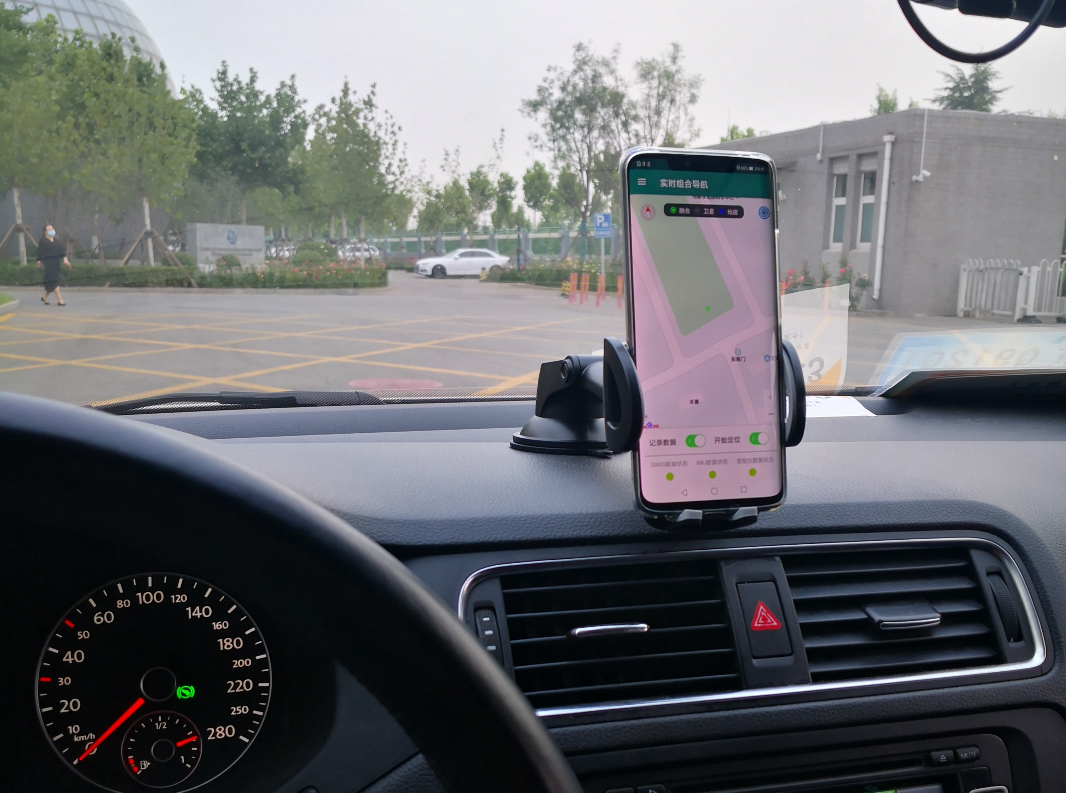
Desired localization approaches:
Any kind of positioning algorithm is admitted.
Description of Datasets (Logfiles)：
- Each logfile is a “txt” file containing multiple rows with different types of data. Each row registers the data received from a particular sensor type in the phone at a given time. The stream of sensor data generated in the phone is stored, row by row, in the logfile in sequence as they are received. Each row begins with an initial header (4 capital letters followed by a semicolon, e.g., ‘ACC’,’MAGN’,’GNSS’ etc.) that determines the kind of sensor read, and several fields separated by semicolon with different readings. This is an extract of a real log file shown as example:
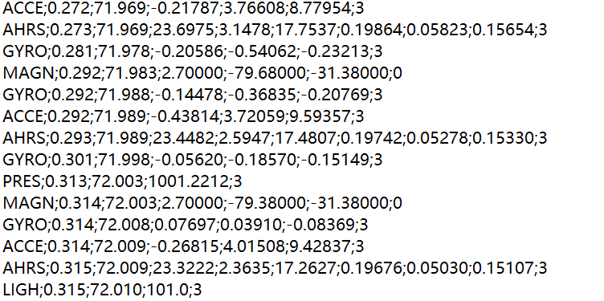
- The detailed list of fields in each sensor’s row, and one specific example, is shown next:
MAGN: the local magnetic field, as measured by the 3-axis magnetometer in the phone
Format | MAGN;AppTimestamp(s);SensorTimestamp(s);Mag_X(uT);Mag_Y(uT);Mag_Z(uT);Accuracy(integer)
Example | MAGN;0.035;8902.708;-20.70000;-34.02000;-19.20000;3
ACCE: the phone’s acceleration, as measured by the 3-axis accelerometers in the phone
Format | ACCE;AppTimestamp(s);SensorTS(s);Acc_X(m/s^2);Acc_Y(m/s^2);Acc_Z(m/s^2);Accuracy(integer)
Example | ACCE;0.034;8902.708;-1.80044;6.41646;7.17303;3
GYRO: measures the phone’s rotation, using the 3-axis orthogonal gyroscopes in the phone
Format | GYRO;AppTimestamp(s);SensorTimestamp(s);Gyr_X(rad/s);Gyr_Y(rad/s);Gyr_Z(rad/s);Accuracy(integer)
Example | GYRO;0.032;8902.705;-0.22846;-0.21930;-0.05498;3
PRES: the atmospheric pressure
Format | PRES;AppTimestamp(s);SensorTimestamp(s);Pres(mbar);Accuracy(integer)
Example | PRES;0.038;8902.726;956.4289;0
LIGH: for light intensity in Luxes
Format | LIGH;AppTimestamp(s);SensorTimestamp(s);Light(lux);Accuracy(integer)
Example | LIGH;0.032;8902.693;292.0;0
GNSS: the Latitude, Longitude and Height estimated from GPS/BD
Format | GNSS;AppTimestamp(s);Latit(º);Long(º);Altitude(m);Bearing(º);Accuracy(m);Speed(m/s); GPS TOW(s);SatInView;SatInUse;
Example | GNSS;0.611; 40.069708; 116.275895; 36.135;0.000;4.0;0.0; 8272.999; 17;15
AHRS: the mobile phone 3D orientation in terms of pitch, roll and yaw
Format | AHRS;AppTS(s);SensorTS(s);PitchX(º);RollY(º);YawZ(º);RotVecX();RotVecY();RotVecZ();Accuracy(int)
Example | AHRS;0.033;8902.705;41.6550;11.7495;-124.0558;0.25038;-0.26750;-0.80406;-2
POSI: ground-truth position (only in calibration files)
Format | POSI; GPS TOW(s);Latitude(degrees);Longitude(degrees);Altitude(m)
Example | POSI; 8272.999; 40.081377, 116.261005, 35.900
- The sampling rate of each type of sensor can be different since it is dependent on the embedded sensor chips used by a particular phone. Typical sampling frequency value for the inertial data is about 100Hz, but we forced the sensor to the maximum rate.
Inputs given to competitors:
- Three sets of test data containing the ground-truth reference data will be provided for competitors to calibrate their algorithms.
Description of the Output File：
For each trial, you must submit a CSV file whose format is now described, and the output frequency is 1 Hz at every integer second (GPS TOW).
- 4 columns:
Column 1: Timestamp in GPS second of week
Column 2: WGS84 latitude in decimal degrees with at least 6 decimal digit resolution
Column 3: WGS84 longitude in decimal degrees with at least 6 decimal digit resolution
Column 4: Altitude in decimal meters with at least 1 decimal digit resolution
- Example:
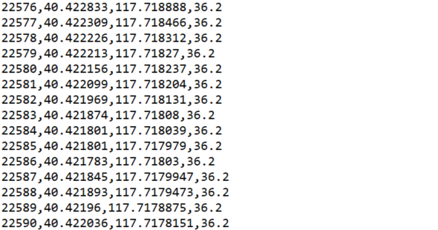
Evaluation criteria：
Following the Evaal evaluation criteria, the 2D positioning error of output points will be evaluated,while the altitude error is not considred in the final evaluation. The final score is evaluated only during the phases where the GNSS is attenuated or absent (that is, the last 25 + 10 minutes). During the test, a DGNSS/FOG-INS reference system with an expected accuracy of 20 cm at 1 Hz will provide the ground truth. Competitors are expected to provide an estimate at every integer second (GPS TOW).
Contact points and information:
For any further question about the database and this competition track, please contact to:
Dongyan Wei (weidy@aircas.ac.cn), Xinchun Ji (jixc@aircas.ac.cn), Aerospace Information Research Institute, CAS (CH)

