Track 6: Smartphone-based Vehicle positioning without additional equipment
Organizational aspects:
Database/dataset download:
- Participants can download the databases (logfiles) from this site: http://evaal.aaloa.org
Competitors can only use the data provided for the competition.
Submission of the post-processed results:
- After processing the evaluation logfiles, participants must submit the position estimates to the contact points of the corresponding track. Each submission must fulfill the format detailed in “Output location file format” described below.
- A participant team can upload up to 3 different contributions, which will be evaluated by the competition organizers. Although the three alternatives will be evaluated on the final test set, only the best one will be considered for the contest.
Submission deadline of the post-processed indoor coordinates:
The deadline for submitting the post-processed results is: November 30th 2020
Competition Goal:
The goal of this track is to evaluate the performance of different integrated navigation solutions based on the sensors of vehicle-mounted smartphone, such as GNSS, MEMS and magnetometer, etc.
Main features of the competition:
- This track is done off-site, so all data for calibration and evaluation is provided by competition organizers in advance. The competition teams can calibrate their algorithmic models with several databases containing readings from sensors of the vehicle-mounted smartphone and some ground-truth positions. Finally, each team will compete using additional database files, but in this case, the ground-truth reference is not given and must be estimated by the competitors. Besides, in order to avoid using map matching method, an irregular driving route is adopted. This is an off-line competition where all competitors have the same data of the testing environment, so performing any additional on-site calibration is not allowed.
- A Huawei mate20 smartphone is used to record raw multi-sensor data in the vehicle scene. During the entire test process, the smartphone is fixedly installed at the front of the vehicle to record the test data. All data is recorded in the TXT log file, which contains the data information of all available signals recorded by the smartphone in real time.
- In the typical urban road conditions, a single test process lasts about one hour and the test route consists of static initial alignment phase, open environment phase, GNSS signal attenuation phase (blocked by the surrounding buildings or trees) and no GNSS signal phase. The driving process of the test vehicle includes going straight, left/right turning, reversing and parking.
- During the phase of data collection, all calibration data and test data use the same vehicle, smartphone and smartphone installation way.
- During the test process, the smartphone is firmly connected to the vehicle body as shown below. The sensor measurement coordinate system is not coincident with the vehicle body coordinate system, so the mounting angles need to be considered.
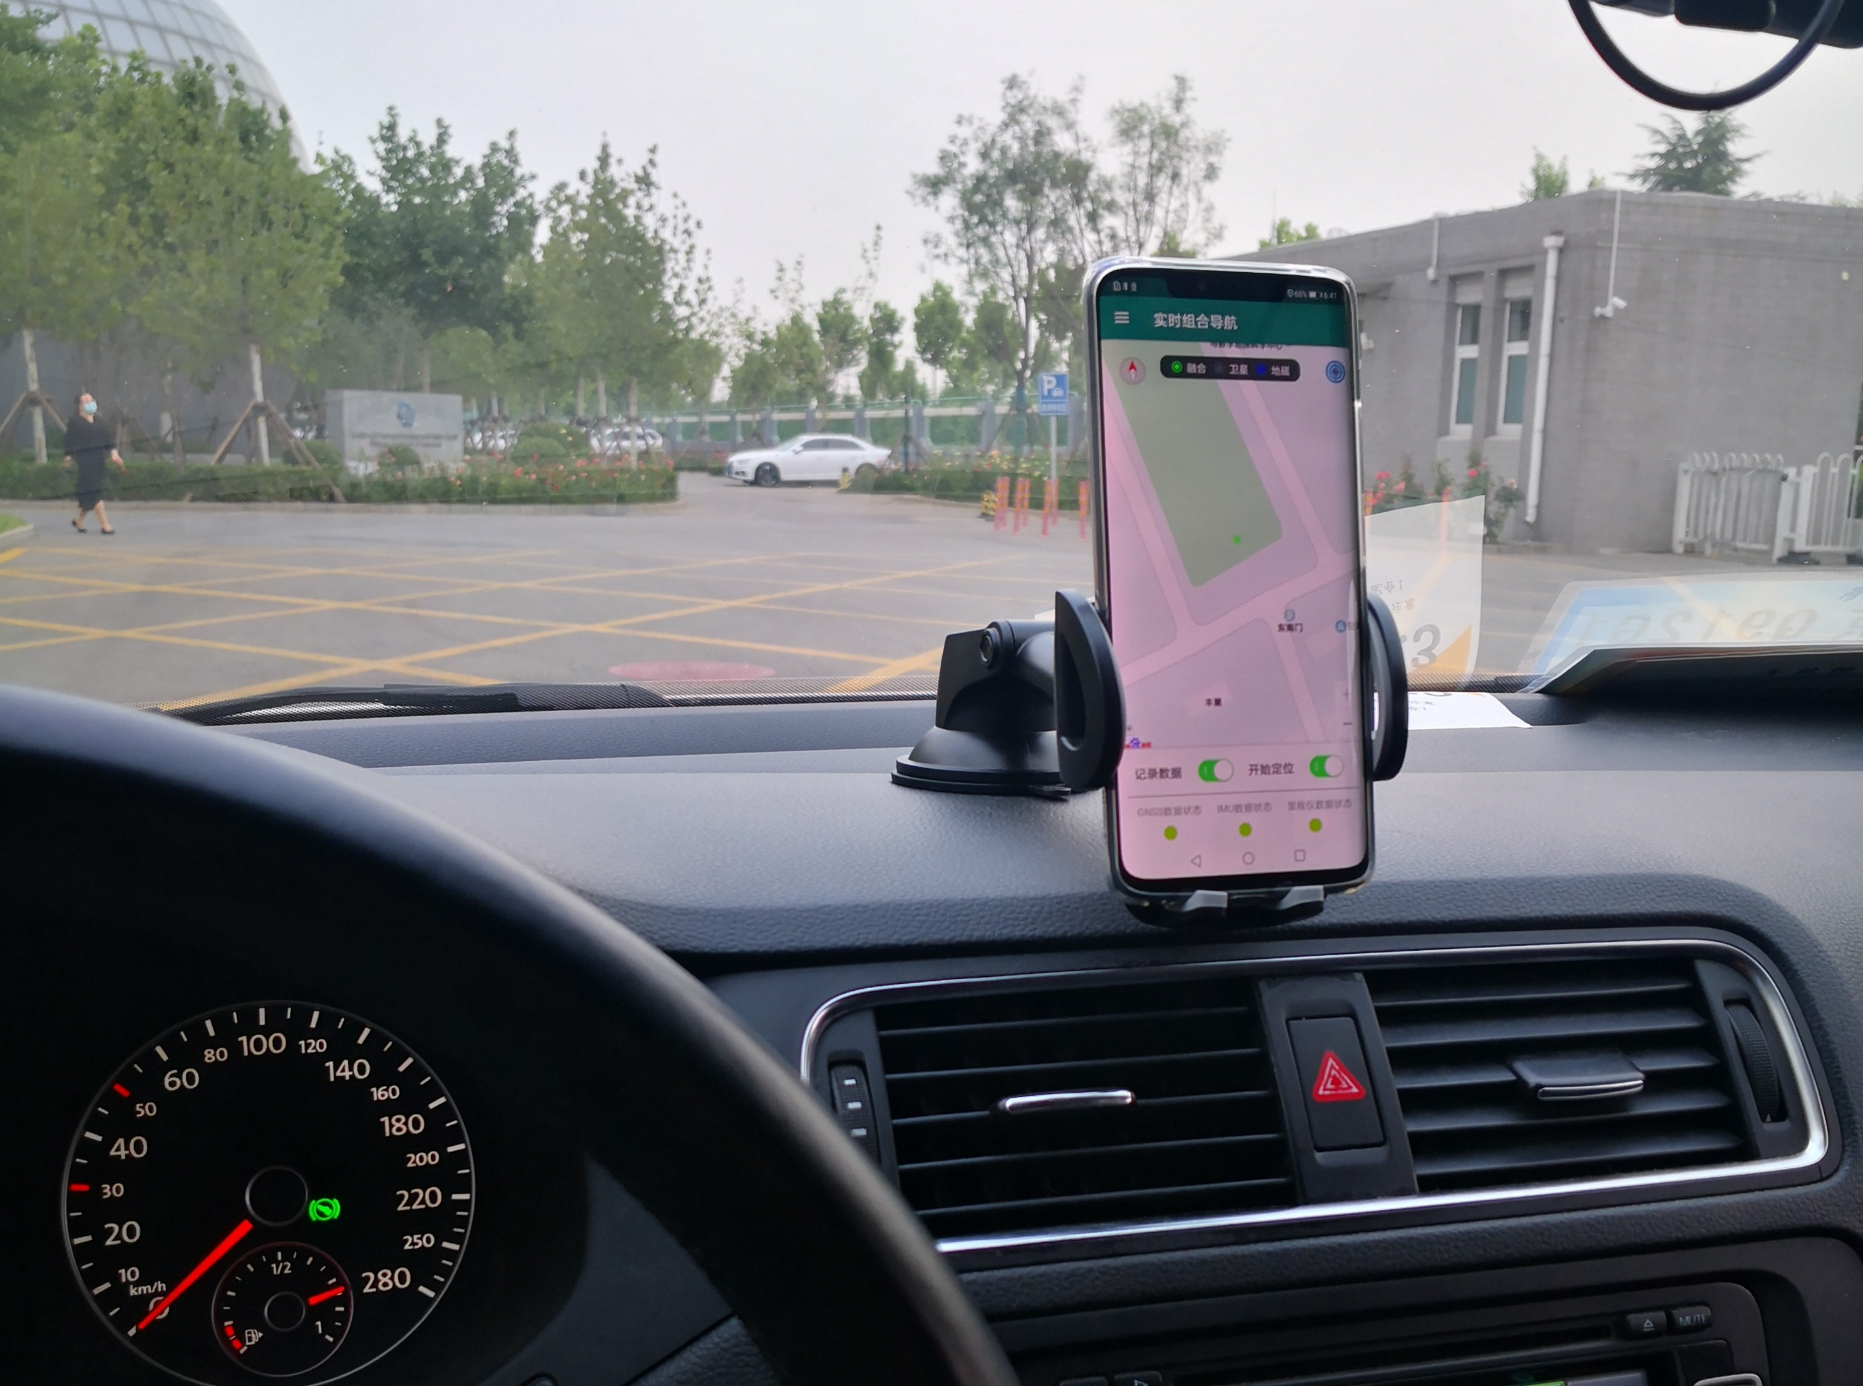
Desired localization approaches:
Any kind of positioning algorithm is admitted.
Description of Datasets (Logfiles)：
- Each logfile is a “txt” file containing multiple rows with different types of data. Each row registers the data received from a particular sensor type in the phone at a given time. The stream of sensor data generated in the phone is stored, row by row, in the logfile in sequence as they are received. Each row begins with an initial header (4 capital letters followed by a semicolon, e.g., ‘ACC’,’MAGN’,’GNSS’ etc.) that determines the kind of sensor read, and several fields separated by semicolon with different readings. This is an extract of a real log file shown as example:
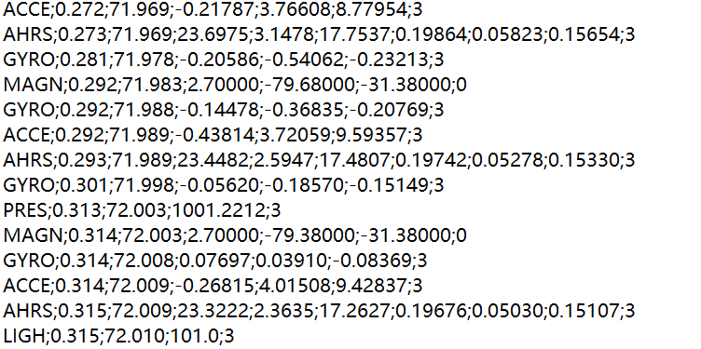
- The detailed list of fields in each sensor’s row, and one specific example, is shown next:
MAGN: the local magnetic field, as measured by the 3-axis magnetometer in the phone
Format | MAGN;AppTimestamp(s);SensorTimestamp(s);Mag_X(uT);Mag_Y(uT);Mag_Z(uT);Accuracy(integer)
Example | MAGN;0.035;8902.708;-20.70000;-34.02000;-19.20000;3
ACCE: the phone’s acceleration, as measured by the 3-axis accelerometers in the phone
Format | ACCE;AppTimestamp(s);SensorTS(s);Acc_X(m/s^2);Acc_Y(m/s^2);Acc_Z(m/s^2);Accuracy(integer)
Example | ACCE;0.034;8902.708;-1.80044;6.41646;7.17303;3
GYRO: measures the phone’s rotation, using the 3-axis orthogonal gyroscopes in the phone
Format | GYRO;AppTimestamp(s);SensorTimestamp(s);Gyr_X(rad/s);Gyr_Y(rad/s);Gyr_Z(rad/s);Accuracy(integer)
Example | GYRO;0.032;8902.705;-0.22846;-0.21930;-0.05498;3
PRES: the atmospheric pressure
Format | PRES;AppTimestamp(s);SensorTimestamp(s);Pres(mbar);Accuracy(integer)
Example | PRES;0.038;8902.726;956.4289;0
LIGH: for light intensity in Luxes
Format | LIGH;AppTimestamp(s);SensorTimestamp(s);Light(lux);Accuracy(integer)
Example | LIGH;0.032;8902.693;292.0;0
GNSS: the Latitude, Longitude and Height estimated from GPS/BD
Format | GNSS;AppTimestamp(s);Latit(º);Long(º);Altitude(m);Bearing(º);Accuracy(m);Speed(m/s); UTCTime(s);SatInView;SatInUse;
Example | GNSS;0.611; 40.069708; 116.275895; 36.135;0.000;4.0;0.0; 8272.999; 17;15
AHRS: the mobile phone 3D orientation in terms of pitch, roll and yaw
Format | AHRS;AppTS(s);SensorTS(s);PitchX(º);RollY(º);YawZ(º);RotVecX();RotVecY();RotVecZ();Accuracy(int)
Example | AHRS;0.033;8902.705;41.6550;11.7495;-124.0558;0.25038;-0.26750;-0.80406;-2
POSI: ground-truth position (only in calibration files)
Format | POSI; UTCTime(s);Latitude(degrees);Longitude(degrees);Altitude(m)
Example | POSI; 8272.999; 40.081377, 116.261005, 35.900
- The sampling rate of each type of sensor can be different since it is dependent on the embedded sensor chips used by a particular phone. Typical sampling frequency value for the inertial data is about 100Hz, but we forced the sensor to the maximum rate.
Inputs given to competitors:
- Three sets of test data containing the ground-truth reference data will be provided for competitors to calibrate their algorithms.
Description of the Output File：
For each trial, you must submit a CSV file whose format is now described:
- 4 columns:
Column 1: Timestamp in millisecond
Column 2: WGS84 longitude in decimal degrees with at least 9 decimal digit resolution
Column 3: WGS84 latitude in decimal degrees with at least 9 decimal digit resolution
Column 4: Altitude in decimal degrees with at least 3 decimal digit resolution
- Example:
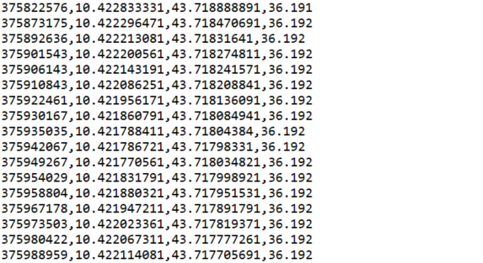
Evaluation criteria：
Following the Evaal evaluation criteria, the three-dimensional positioning error of all output points will be evaluated.
Contact points and information:
For any further question about the database and this competition track, please contact to:
Dongyan Wei (weidy@aircas.ac.cn), Xinchun Ji (jixc@aircas.ac.cn), Aerospace Information Research Institute, CAS (CH)

